Looking at Linux Processes

As mentioned before, one of the most important functions of the OS kernel is to manage processes.

Processes in Linux will have, among (many) other things, an owner’s ID, a process name, a process ID (PID), a process state, PID of the parent process and length of time the process has been running. Of these, the PID is probably the most used parameter as it is used in several process control commands.

Exercise 1: Viewing a basic set of attributes of processes having the same user ID as the user and associated with the same terminal as the caller using ps

By simply typing

ps

you can see immediately a few of the processes which are currently running on your machine. Notice that you get back a number of pieces of information. The first is PID itself and this will be unique for every process that exists. After this comes the TTY information that just gives the name of the terminal to which the listed processes are attached – these terminals always have the name pts/n, where n is some positive number. Generally you will find that a number of processes attach to the same terminal, the one that you are currently using. The TIME information tells you how long (in h:m:s) the process has been running on the CPU. Note, for example, that the ps process itself is listed as 0 seconds – this is because it only took a fraction of a second for the ps process itself to execute on the CPU. The last piece of data, CMD, is obviously enough, the process name.

Note here also that the bash process has the smallest PID and is called the session leader process. Recall the bash shell is a command interpreter process.
All other processes created in this shell are its children or grandchildren. In Linux the execution of a shell process, such as bash, starts a session and the processes that execute under it are the components of that session.

Exercise 2: Viewing the basic set of process attributes plus the states of these for processes associated with a terminal or having the same UID as the user using ps a

Now type

ps a

Now along with the previous data, you can see the states – STAT - of the various processes involved. Some of the possible states in Linux are as follows (don’t worry that these may not be exactly in sync with those process states covered in lectures, which is a more general discussion of the topic as it applies to all OS, not just Linux). This is the first character in the STAT column, you may ignore the other characters.

Process State Meaning
D Uninterruptible sleep (usually IO)
R Running or runnable (on run queue)
S Interruptible sleep (waiting for an event to complete)
T Stopped, either by a job control signal or because it is being traced.

Generally, processes will be in either the sleeping (i.e. blocked waiting for i/o or for some other reason) state or the runnable state, meaning that it is in the ready queue, awaiting the CPU to be assigned to it. You will see that the bash process itself is in a sleeping state and this is because, at the time the ps a command is executed, bash is blocked waiting for its child process (ps) to complete execution. Once ps has completed its execution, bash “wakes up” from its sleep state, becoming runnable once more and gives you back your prompt.

Exercise 3: Viewing detailed information for all processes including CPU time used, memory used and user names using ps aux

In Windows, we used the Task Manager to see the applications/processes that are running on the system. We also saw how much memory/CPU was assigned to each process. We can do the same in Linux using the aux option with ps command.

Now type

ps aux

%mem is a reflection of the % of RAM being used by the process concerned and VSZ is the Virtual Size of a memory image for a process (program code + data + stack) in blocks and reflects the total amount of virtual memory a process uses. RSS is the Resident Set Size and is the amount of physical RAM taken up by the process in KB and is a more accurate reflection of how much system memory a process uses. Naturally a relationship exists between %mem and RSS. CPU gives the % of the processors time taken up by the process since the last display.

To view processes associated with the current user, use the following command:
ps ux or ps U uname e.g. ps U lt000xxxxx

You can put a process running in the background by typing the command followed by a space and the & character.
The "yes" command as an easy method for an example of a program that runs continually. The "yes" command outputs the string "y" until it is killed or stopped. When the output is ported to the /dev/null (null device or bit bucket), the output is basically dumped. Therefore this command is harmless, but is a good demonstration. To put the process in the background, append an "&" character to the end of the command as shown below.
yes > /dev/null &
The system will respond with a job number and process ID or PID similar to:
[1] 10419
To bring the process to the foreground, use the fg command as follows:
fg %1

Exercise 4: examine the processes displayed and note which one has the highest CPU value and which has the highest %mem value. Also note any two that are in a runnable state.

Highest on CPU: tpb___________________________________
Highest on %mem: gv__________________________________
In a runnable state: init_______________________________________

The Unix top command is designed to help users determine which processes are running and which applications are using more memory or processing power than they should be.

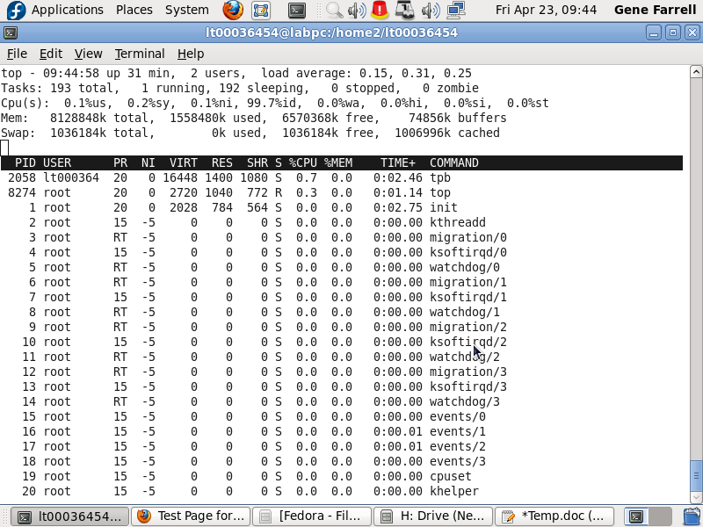
Exercise 5: Start Firefox and run the ps ux command. Note the PID for the Firefox process. Run the kill PID command to close Firefox.

Exercise 6: Check if the Apache webserver is running on your system:
Switch to root – su root
Check status – service httpd status
Run apache – service httpd start
Go back and re-issue the ps aux command and you should see a number of new process entries associated with Apache.
To stop processes by name: killall {Process-name} $ killall httpd

Note:
To stop the Apache service normally, issue the following command: service httpd stop
If you would like the Apache service to start automatically when the system boots, this can be achieved by running the following command:
chkconfig --level 3 httpd on

Testing the Web Server
Once the installation is complete the next step is to verify the web server is up and running. To do this fire up the web browser by clicking on the Firefox logo in the top desktop panel and enter 127.0.0.1 in the address bar (127.0.0.1 is the loop-back network address which tells the system to connect to the local machine). The browser should load the Fedora Test Page.
Exercise 7:
To configure the Apache service using the Service Configuration Tool, type system-config-services in a terminal window and scroll down the list of services until you find httpd. Select the item in the list and click on the Start button. To ensure the services starts automatically on reboot, also click in the Enable toolbar button.
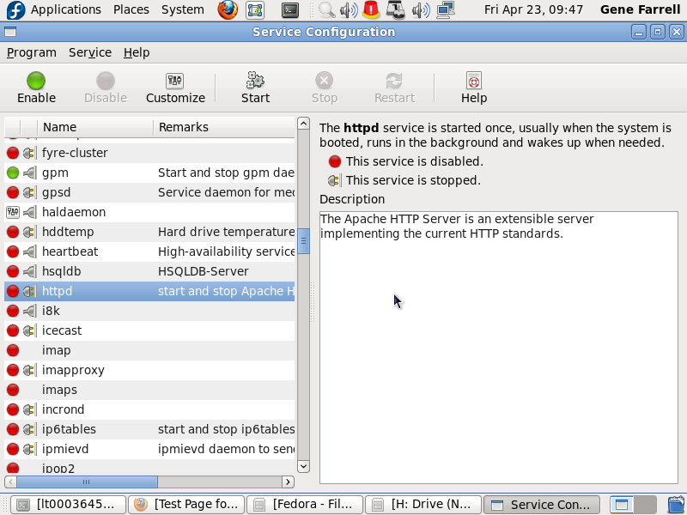

Exercise 8: Unmounting Devices, Logging Out and Shutting Down

Before you log off it is good practice to close all open windows and to unmount any devices such as memory sticks that you have attached to the system. To unmount a device simply right-click its icon on the desktop and select “Unmount Volume”. Doing this helps to prevent possible data loss and makes the shutting down process cleaner.

Now, to log off simply go to System->Log Out t00012345. Doing this will log you off, save all your session settings, and take you back to the console but the system will still remain operational.

In order to shut the system down and reboot, you need to hit ALT+CTRL+DEL at the console. This will begin the shutdown process and reboot the machine.

